Enquirers’ Form
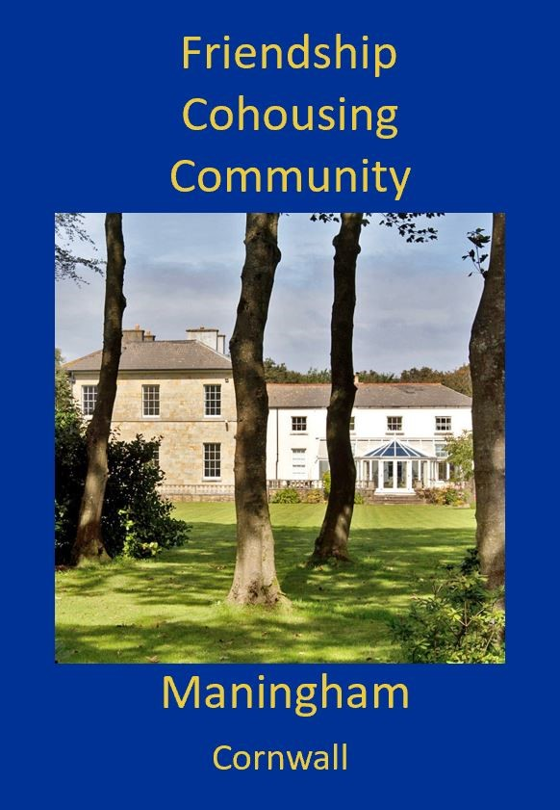
In all people we look for goodness
www.friendshipcohousing.org.uk

We are delighted you wish to know more about becoming a member of the Friendship Cohousing Community at Maningham! Becoming an enquirer is a first stage towards being considered for membership. If all goes well, you will be invited to join our waiting list, then we may invite you to come and live with us as a prospective member for three months when a space becomes available. Please fill in this form and send it to this email address enquiriesfch@gmail.com
Friendship Cohousing Community Vision Statement
Our vision is to:
- Live by the Quaker values of truth, peace, equality and simplicity
- Be a loving community looking for goodness in all people
- Become a pattern and example of sustainable living
- Be an inspirational educational centre teaching awareness, well-being and practical skills to help people to survive and thrive
- Hold Maningham as a nurturing spiritual place offering care and support
- Maintain, at our core, love and care for the planet and all beings, as we face a climate and ecological emergency
Agreed December 2020

I’d like to be an enquirer. I agree to the above vision. I have filled in the form on the second page.
Signed ……………………………………………………………….……..………. Date………………………………………………………….……..
By signing this form you agree to the circulation of your contact and other details amongst our membership. We shall follow the Data Protection Act and your details will not be used for any purpose other than informing you about the project’s progress and answering your questions. You can unsubscribe and withdraw from being an enquirer at any time. Being an enquirer is free.
What happens next?
- Unless there is a problem with proceeding (such as too many enquirers to cope with!) you will receive an email from us accepting you as an enquirer.
- As an enquirer, you will be invited to come and visit us at Maningham or to have a chat with 3 or 4 of us on Zoom. This is not an indication that you are being considered to be a member, just an opportunity for you to meet us and say hello!
- Being an enquirer is a first stage towards being considered for membership. During this first stage we invite you to study our brochure (which you can download from our website) and ask questions. It is important for you to find out whether being part of our community would meet your needs.
- You will receive information about the process of becoming a member of Friendship Cohousing Limited. We may offer you a chance to be on a waiting list or we may wait until we have a space coming free (due to a member leaving) before we invite you to apply for the next stage.

Contact details (please fill in one form per person)

- Full name
- Date of birth and age
- Name of your spouse, partner, children if applicable
- Important personal information (e.g. disability) if any

- Email address
- Postal address
- Telephone numbers (landline and mobile)

About you

- What are your spiritual leanings spiritual practices? Are you a Quaker or an active participant in a religion?
- What are the main skills that you can bring to the community?

- You don’t need capital to join our community but we’d like to know if you have some. How much?

Please add any additional key points you’d like us to know, and say why you would like to join (go onto another page if you wish).

Please complete a “Who Am I?” with a photograph (format advice is on our website) and send this too

This version of the form dated 8th June 2021

