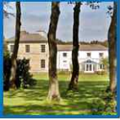
Friendship Cohousing Community
at Maningham
Information for Enquirers
Would you like to live as part of the Friendship Cohousing Community at Maningham? This leaflet will give you more information to help you decide if Maningham is for you.
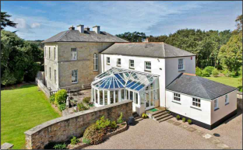
Maningham is close to the village of Illogan near Redruth, Cornwall. There is the attractive Portreath beach, just a short walk
through the woods and Tehidy Country Park is close by.
The house was built as a rectory by Francis Basset in 1785 The eastern extension was built in 1820 and the kitchen extension, conservatory and buildings in the yard built
later. There are 5 acres of beautiful landscaped gardens and woodland.
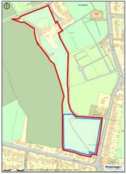
Friendship Cohousing Community
We purchased Maningham in March 2021. Our community consists of a diverse group of people who are spiritually aware and welcome all faiths and none.
We have private units for residents and a beautiful house with lovely communal spaces. We are accepting of all dietary preferences including vegans, vegetarians and an ethical omnivorous diet.
We currently have a few chickens, and we have started growing food and creating a forest garden. We wish to develop a resilient way of living, increasing our sustainable water and energy.
This is a relatively new community that is still learning and growing
together. Our vision is to develop links with local people and
have regular open days, workshops for learning new skills and
spiritual retreats. We aspire to develop practices of self-sufficiency, permaculture, herbal medicine and spiritual awareness .
www.friendshipcohousing.org.uk enquiriesfch@gmail.com

Friendship Cohousing Community Vision Statement
Live by the values of truth, peace, equality and simplicity
Be a loving community looking for goodness in all people
Become a pattern and example of sustainable living
Hold Maningham as a nurturing spiritual place offering care and support
Maintain, at our core, love and care for the planet and all beings

What we're offering and looking for
We are offering a simple place to live in an intentional community, where you will have a fairly small private unit for your own quiet time, and also be part of a group of people sharing day- to day activities and tasks together We frequently cook and eat together, buy food to share in bulk, share growing spaces in the garden Groups of us take on tasks such as shopping, cleaning and running the finances. We also have plenty of time to enjoy the peace and ‘do our own thing’
We are seeking people committed to the idea of living with care and compassion in our community, who are mindful and spiritually aware, who wish to live close to nature and help each other through all difficulties with kindness You will need to be prepared to devote time and energy to this learning work and to grow as a community with other members An important part of this is being able to look within yourself
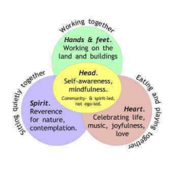
Joining process
If you are interested in joining Friendship
Cohousing Community please come and
visit us for an Enquirers' Day or an Interest
Weekend
If you wish to continue, you will join our
waiting list. When a private unit is available
we will invite you to come as a 'guest
member' for 3 months. During this time we
shall focus on getting to know each other and
seeing if we are a good match for each other.
As a committed member, there is no individual ownership or renting. Some members invest capital, while others contribute a licence fee. Not everyone needs capital to live here but we do
need a balance of people with and without
capital. We shall explain more about our financial structure when you visit us.
www.friendshipcohousing.org.uk enquiriesfch@gmail.com

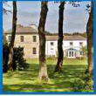
We periodically host an Enquirers’ Day when typically between 10am -
4pm you can gain a taste of life here at Maningham. The cost is £30 including lunch and refreshments. You will be shown round the house and garden, meet our members, and share in a talk about the legal and financial set-up and how we manage the community. If you wish to stay the night, we may have some rooms available. If we don’t we can make some suggestions for local places to stay.
Please contact us for other options.
Private Units
We have divided Maningham up into 19 private units plus shared areas as shown on this plan 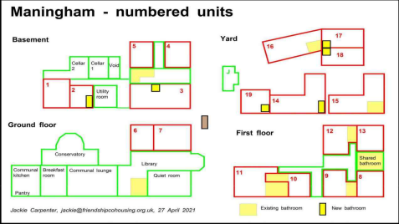
www.friendshipcohousing.org.uk enquiriesfch@gmail.com
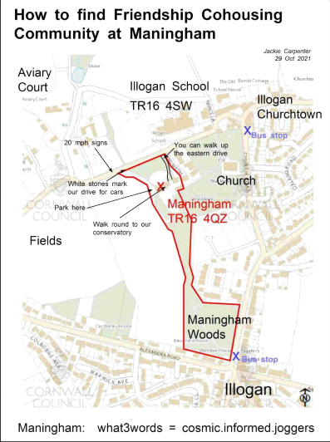

www.friendshipcohousing.org.uk enquiriesfch@gmail.com

